

**LAB ASSIGNMENT 4**

**SUBMITTED BY:** Kulsoom Khurshid

**REGISTRATION #:** SP20-BCS-044

**COURSE:** Operating System

**SUBMITTED TO:** MA’AM ZAHIDA WALIYAT

**QUESTION 1**

Write a shell script declares two integer type arrays of size 30. At runtime, the program asks the user to enter values in theses arrays (it is up-to the user how many values he/she enters). Once the arrays are populated, finds how many values are same in both arrays.  
COMMANDS AND OUTPUT:

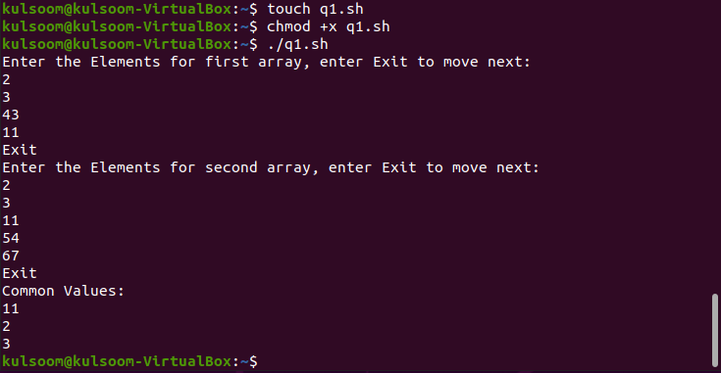

CODE:

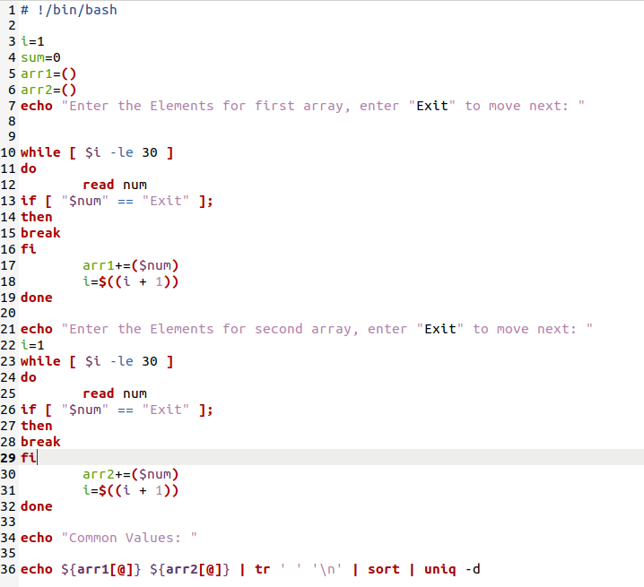

**QUESTION 2:**

**Part1**

Write a shell script the that ask user to enter total number of array elements, reads input from keyboard and then stores it in array .and print them in descending order.

**Part2**

Find prime number of the values.

COMMANDS AND OUTPUT:

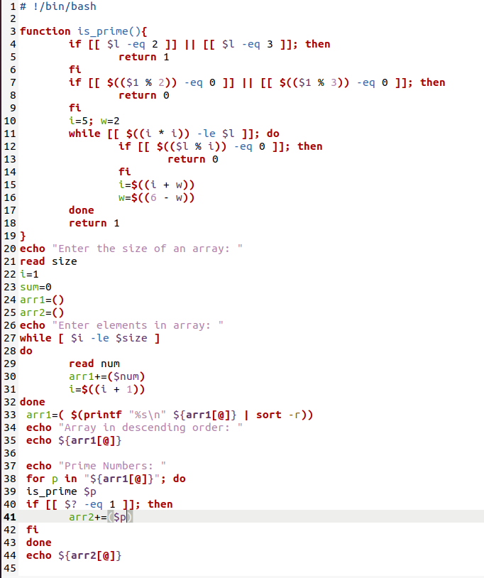

CODE:

